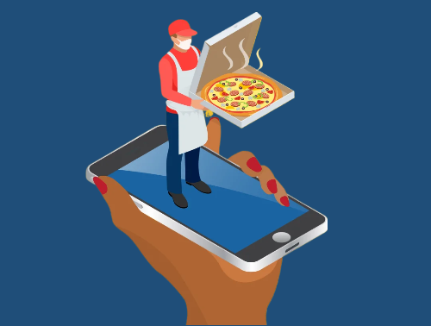



**Human Computer Interaction**

**Project**

**2024**

**-**

**2023**

**Fast Food Delivery**

Team members:

* Eslam Hany Elsayed Zoghla (Section 2) - Gamal Adel Gamal Khalifa(Section 3)
* Taha Ibrahim Taha Ibrahim (Section 4) - Hadi Rabee Kamel Alam (Section 8)

**Computer Science Departement,**

Instructor :

*Associate Prof*. *Wafaa Shalash*

**Acknowledgment**

I would like to express my deep gratitude and thank you to **Dr. Wafaa Shalash**, **Eng. Mawada, Eng. Mohamed Raafat** and **Eng. Ahmed Mostafa,** who did put effort into encouraging us to do a great job, providing our team with valuable information and advising us to be better every time. Thanks for the continued support and kind communication which has had a huge impact in terms of feeling interested about what we are working on. We are truly grateful to them.

Table of Contents

**1-** **Introduction** 5

**2-** **Heuristic Evaluation** 6

**2.1 Nielsen's 10 Usability Heuristics** 6

1 - Visibility of System Status: 6

2 - Match Between System and the Real World 7

3 -User Control and Freedom 8

4- Consistency and Standards: 9

5- Error Prevention 10

6- Recognition Rather Than Recall 11

7- Flexibility and Efficiency of Use 12

8- Aesthetic and minimalist design 13

9- Help users recognize, diagnose, and recover from errors 14

10- Help and documentation 15

**2.2 Schneiderman’s 8 Golden** 16

**3-** **Sketch** 17

**4-** **Wire Frame** 20

**Usability Test Script** 29

**Schneiderman’s 8 Golden** 32

**test Planing** 33

**Test plan** 33

**Objectives** 33

**Tasks** 33

**User target profile** 34

**Test Cases, test scenarios and prioritizing tasks** 35

1. Login 35

2. Log out 35

3. Add Nationality 36

4. Edit Nationality 36

5. Add Admin 36

6. Delete Student 37

7. Delete Report 37

8. Delete Course 38

9. Add Exam 38

10. Add Multiple Choice Question (3 choices, without image) 38

11. Add Essay Question (without image) 39

12. Create Course 39

13. Update Profile Image 40

14. Show Exam Page (Student & Instructor) 40

**Post-test survey questionnaires** 41

**Test execution** 45

**Guiding Participants and Gathering Feedback** 45

**Usability Testing PERFORMANCE METRICS of Admin** 48

**Three levels of criteria** 48

**Result of usability test** 49

**Task completion rate** 49

**Usability Testing PERFORMANCE METRICS of Instructor** 50

**Three levels of criteria** 50

**Result of usability test** 51

**Task completion rate** 51

**Usability Testing PERFORMANCE METRICS of Student** 52

**Three levels of criteria** 52

**Result of usability test** 53

**Task completion rate** 53

**Reference** 54

# **Introduction**

Overview: The Fast-Food Delivery app is designed to facilitate quick and easy ordering of fast food for delivery. Users can browse menus, place orders, track deliveries, add credit cards, chat or call with staff, promo code for discount, access the app settings, and manage their accounts.

Target Users: The app targets busy professionals, students, and anyone looking for convenient and fast-food delivery options.

Primary Tasks: Browsing for food, ordering food, tracking deliveries, managing personal information, and accessing customer support.

# **Heuristic Evaluation**

## **2.1 Nielsen's 10 Usability Heuristics**

### 1 - Visibility of System Status:

The app provides immediate feedback during loading, processing orders, and payment confirmation.

Weaknesses: Lack of a progress indicator during location setup or while applying promo codes.

|  |  |
| --- | --- |
|  | **A screenshot of a phone** |

### 2 - Match Between System and the Real World

Use of familiar terminology like "Cart," "Favorites," and "Order Now".

|  |  |
| --- | --- |
| A screenshot of a phone | A screenshot of a cellphone |

### 3 -User Control and Freedom

Users can easily add/remove items from the cart and undo actions.

Weaknesses: No apparent way to undo a location setting or a promo code application.

|  |
| --- |
|  |

### 4- Consistency and Standards:

Consistent layout and design patterns throughout the app.

|  |  |
| --- | --- |
|  |  |

### 5- Error Prevention

Confirmation prompts actions like deleting an item from the cart or logging out.

Weaknesses: Potential for input errors during location setup without sufficient guidance.

|  |  |
| --- | --- |
|  |  |

### 6- Recognition Rather Than Recall

Visual cues and labels are clear, making navigation intuitive.

|  |  |
| --- | --- |
|  |  |

### 7- Flexibility and Efficiency of Use

Provide shortcuts, accelerators, and customizable settings to accommodate users with varying levels of expertise and preferences. Allow experienced users to perform tasks more efficiently through shortcuts and advanced features.

Ctrl + F for Favorites, Ctrl + S for Search, …

|  |  |
| --- | --- |
|  |  |

### 8- Aesthetic and minimalist design

Keep interfaces clean, simple, and free of unnecessary clutter. Emphasize essential elements.

|  |  |
| --- | --- |
|  |  |

### 9- Help users recognize, diagnose, and recover from errors

Provide clear error messages that explain the problem and suggest solutions.

|  |  |
| --- | --- |
|  |  |

### 10- Help and documentation

Offer comprehensive and accessible help resources to assist users in understanding and using the interface.

|  |  |
| --- | --- |
|  |  |

## **2.2 Schneiderman’s 8 Golden**

|  |  |  |
| --- | --- | --- |
| **Mark Complete** | **Questions to consider** | **The principles** |
| **Checkmark with solid fill** | Is the style of this element maintained across your site/app? Is this content placed in the correct location according to the site hierarchy? Does this follow the conventions for your chosen platform? How can you make your designs more consistent? | 1 – Strive of Consistency |
| **Checkmark with solid fill** | Are there shortcuts available for your more experienced users? Who is this product designed for? Will there be a need to consider experienced users? How can you make it easier and quicker for experienced users? | 2 – Enable frequent users to use shortcuts |
| **Checkmark with solid fill** | Does the user know where they are at in the process? Does the user know what they have done after performing this action? How are you communicating this feedback to your user? | 3 – Offer information feedback |
|  | Does the user have to do any guessing here? Is it clear and obvious enough for your intended audience? Are there any next steps for the user? How are you communicating the system status with the user? | 4 – Design dialogue to yield closure |
| **Checkmark with solid fill** | Have you done everything imaginable to prevent this error from happening on your end? Is this error avoidable in the first place? If the user does make an error, how easy is it for them to fix it? | 5 – Offer simple error handling |
| **Checkmark with solid fill** | How many steps does the user have to take to reverse their actions? Will the user quickly realize they need to reverse the action in the first place? How can you make your users detect the possibility of reversal? | 6 – Permit easy reversal of actions |
| **Checkmark with solid fill** | Will the user feel in control at this specific touch point in your app? Will they be surprised in an unpleasant manner? Does the site feel easily  navigable? Does the user feel safe and in control? How can you make the user feel more safe and in control? | 7 – Support internal locus of control |
| **Checkmark with solid fill** | Are there enough visual cues here for the user to find the functionality or item? Do they have to remember things to understand what's going on? How can you help the user recall? | 8 – Reduce short-term memory load |

# **Sketch**

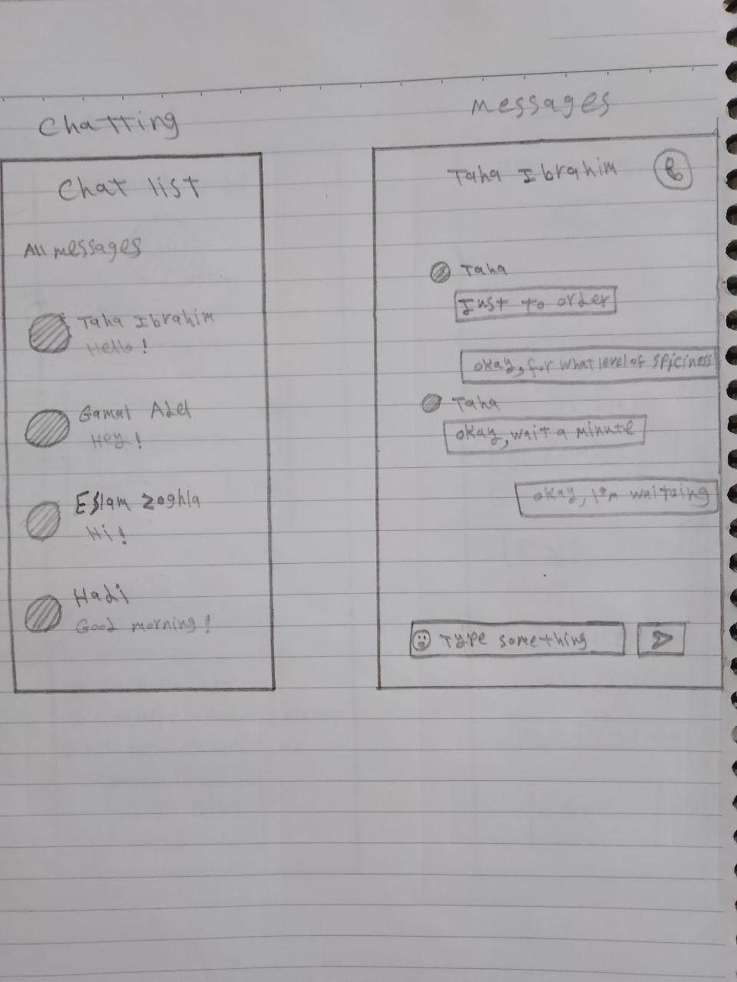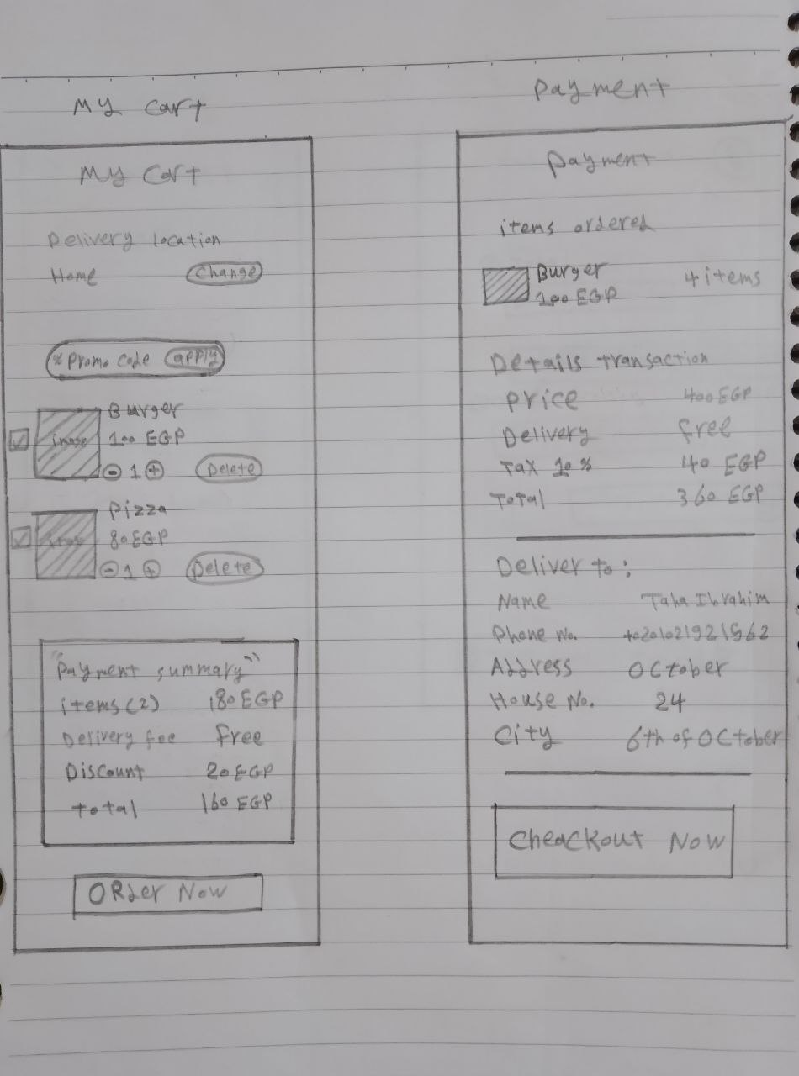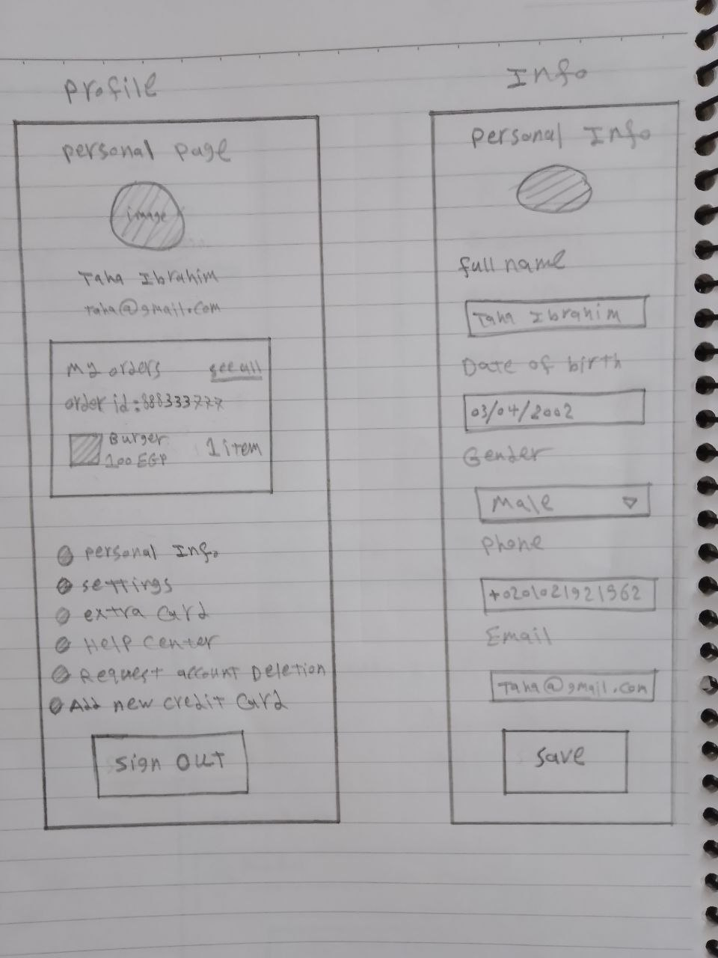

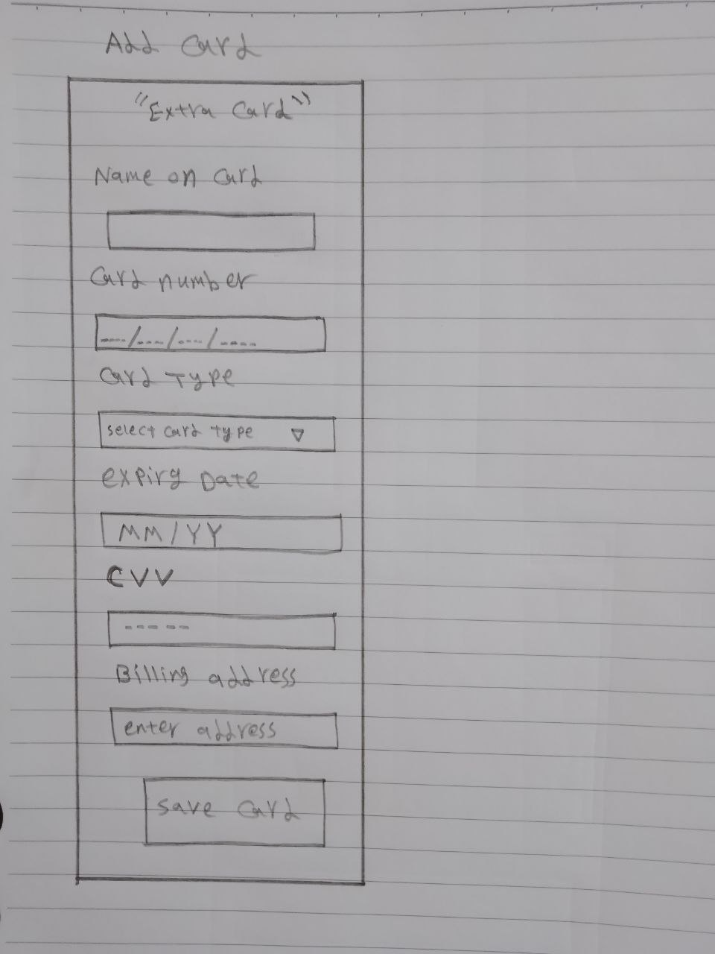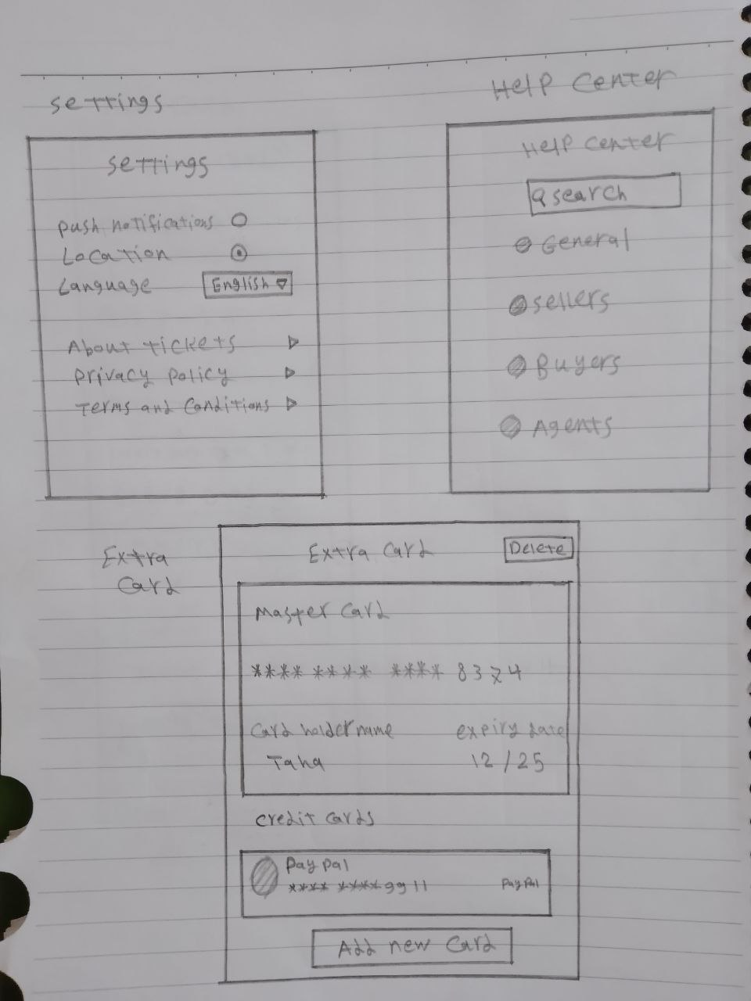

# **Wire Frame**

|  |  |
| --- | --- |
|  |  |
|  |  |

|  |  |
| --- | --- |
|  |  |
|  |  |

|  |  |
| --- | --- |
|  |  |
|  |  |

|  |  |
| --- | --- |
|  |  |
|  |  |

|  |  |
| --- | --- |
|  |  |
|  |  |

|  |  |
| --- | --- |
|  |  |
|  |  |

|  |  |
| --- | --- |
|  |  |
|  |  |

|  |  |
| --- | --- |
|  |  |
|  |  |

|  |  |
| --- | --- |
|  |  |

# The bright side of AI in teaching and learning - The Academic**Usability Test Script**

**Interactive E-learning platform powered by AI**

**Usability test**



**Introduction:**

1. Welcome to our usability test for the E-Learning website! Thank you for participating.
2. The purpose of this test is to gather feedback on the usability and user experience of our website to help us make improvements.
3. During the test, I'll ask you to complete a series of tasks using the website. Please think aloud as you go through the tasks so we can understand your thought process.
4. Your feedback is invaluable to us, and there are no right or wrong answers. We're interested in your honest opinions and experiences.
5. Before we begin, could you please tell me a bit about your experience with e-learning platforms? Have you used any other e-learning websites before?

**Participant Background:**

1. Can you tell me your age, occupation, and level of familiarity with e-learning websites?
2. Have you used this E-Learning website before, or is this your first time using it?

**Instructions:**

1. I'll provide you with a series of tasks to complete using the website.
2. Please perform each task to the best of your ability. If you encounter any issues or have any questions, feel free to ask.
3. Remember to think aloud as you go through the tasks. This will help us understand your thought process and any challenges you encounter.
4. Once you've completed each task, we'll discuss your experience and gather feedback.

**Task Scenarios:**

**Admin Tasks:**

1. Login: Log in to your admin account using your username and password. (Min: 5 clicks, Max: 7 clicks)
2. Add Nationality: Add a new nationality to the system. (Min: 3 clicks, Max: 5 clicks)
3. Edit Nationality: Edit an existing nationality in the system. (Min: 4 clicks, Max: 6 clicks)
4. Add Admin: Add a new admin to the system. (Min: 7 clicks, Max: 10 clicks)
5. Delete Student: Remove a student from the system. (Min: 3 clicks, Max: 6 clicks)
6. Delete Report: Remove a report from the system. (Min: 2 clicks, Max: 5 clicks)

**Instructor Tasks:**

1. Delete Course: Remove a course from the system. (Min: 2 clicks, Max: 5 clicks)
2. Add Exam: Create a new exam for a course. (Min: 5 clicks, Max: 7 clicks)
3. Add Multiple-Choice Question: Add a multiple-choice question with an image. (Min: 12 clicks, Max: 16 clicks)
4. Add Essay Question: Add an essay question without an image. (Min: 9 clicks, Max: 12 clicks)
5. Create Course: Create a new course. (Min: 23 clicks, Max: 27 clicks)

**Student Tasks:**

1. Update Profile Image: Change your profile picture. (Min: 6 clicks, Max: 10 clicks)
2. Show Exam Page: Navigate to the exam page. (Min: 5 clicks, Max: 8 clicks)

**Observation and Note-Taking:**

1. As you complete each task, I'll be observing your interactions with the website and taking notes on your actions, behaviors, and verbal feedback.
2. Please feel free to share any thoughts, frustrations, or suggestions you have as you navigate through the website.

**Follow-Up Questions:**

1. After each task, I'll ask you a few follow-up questions to gather additional insights and feedback.
2. These questions may include asking about your overall experience, any difficulties you encountered, and any suggestions you have for improvement.

**Wrap-Up:**

1. Thank you for completing the tasks and providing your feedback. Your input is incredibly valuable to us.
2. Is there anything else you'd like to share before we conclude the test?

**Closing:**

1. Thank you again for participating in our usability test. We'll be reviewing your feedback and using it to improve the E-Learning website.
2. If you have any further questions or feedback, please don't hesitate to reach out to us.

# **Schneiderman’s 8 Golden**

|  |  |  |
| --- | --- | --- |
| **Mark Complete** | **Questions to consider** | **The principles** |
| **Checkmark with solid fill** | Is the style of this element maintained across your site/app? Is this content placed in the correct location according to the site hierarchy? Does this follow the conventions for your chosen platform? How can you make your designs more consistent? | 1 – Strive of Consistency |
|  | Are there shortcuts available for your more experienced users? Who is this product designed for? Will there be a need to consider experienced users? How can you make it easier and quicker for experienced users? | 2 – Enable frequent users to use shortcuts |
| **Checkmark with solid fill** | Does the user know where they are at in the process? Does the user know what they have done after performing this action? How are you communicating this feedback to your user? | 3 – Offer information feedback |
|  | Does the user have to do any guessing here? Is it clear and obvious enough for your intended audience? Are there any next steps for the user? How are you communicating the system status with the user? | 4 – Design dialogue to yield closure |
| **Checkmark with solid fill** | Have you done everything imaginable to prevent this error from happening on your end? Is this error avoidable in the first place? If the user does make an error, how easy is it for them to fix it? | 5 – Offer simple error handling |
| **Checkmark with solid fill** | How many steps does the user have to take to reverse their actions? Will the user quickly realize they need to reverse the action in the first place? How can you make your users detect the possibility of reversal? | 6 – Permit easy reversal of actions |
| **Checkmark with solid fill** | Will the user feel in control at this specific touch point in your app? Will they be surprised in an unpleasant manner? Does the site feel easily  navigable? Does the user feel safe and in control? How can you make the user feel more safe and in control? | 7 – Support internal locus of control |
| **Checkmark with solid fill** | Are there enough visual cues here for the user to find the functionality or item? Do they have to remember things to understand what's going on? How can you help the user recall? | 8 – Reduce short-term memory load |

# **test Planing**

## **Test plan**

outlines the strategy and approach for conducting usability testing on our e-learning website. The goal is to identify usability issues and gather user feedback to improve the overall user experience, at first we invite 11 member to test our platform by asking them to accomplish a finite number of tasks which we defined, These tasks are divided into tasks for students, Instructors, and admins, These tasks are prioritized based on importance and The number of clicks for each task by each user is recorded. Based on the number of clicks, it is determined whether the website and design are clear to the participants or not.

## **Objectives**

* Evaluate the ease of use of the login and logout processes.
* Assess the efficiency of admin tasks like adding and editing nationalities, adding admins, and deleting students or reports.
* Determine the usability of instructor functionalities such as deleting courses, adding exams, and creating courses.
* Measure the effectiveness of student tasks like updating profile images and accessing exam pages.
* Also ensuring that the website design is clear and easy to use for all participants
* Ensuring that all steps are clearly understood by the participants.
* Providing some recommendations that will benefit the design to reduce issues and thus improve the overall user experience.

## **Tasks**

our tasks are divided into three types of tasks per each actor (Student , Instructors , Admins) :

1: Perform login with a valid username and password.

2: Log out from the system.

* Student tasks :

1. update the profile image.
2. Access the exam page.

* Instructor tasks:
  1. Create a new course.
  2. delete a course.
  3. Add a new exam.
  4. Add one multiple choose Question with default choices (3) Without image
  5. Add one essay Question without image
* Admin tasks:

1. add a new nationality.
2. Edit an existing nationality.
3. Delete a student from the system.
4. Add a new admin to the system.
5. delete student reports

## **User target profile**

* Primary Users:

Students, Instructors

* Secondary Users:

Administrators

* Experience Levels:

Novice Users: Little to no prior experience with e-learning platforms.

Intermediate Users: Some experience with e-learning platforms.

Expert Users: Extensive experience with e-learning platforms.

## **Test Cases, test scenarios and prioritizing tasks**

### 1. Login

* **Objective**: Evaluate the ease and efficiency of the login process.
* **Criteria**: Excellent if 5, Acceptable if completed in 7 clicks, unacceptable if 8+ clicks.
* **Steps**:
  1. Navigate to the login page.
  2. verify reading of the username tips
  3. Enter username.
  4. Enter password.
  5. Click on the login button.

### 2. Log out

* **Objective**: Evaluate the ease and efficiency of the logout process.
* **Criteria**: Excellent if 3, Acceptable if completed in 4 clicks, unacceptable if 5+ clicks.
* **Steps**:
  1. Locate the logout button.
  2. Click on the logout button.
  3. Confirm logout (if needed).

**- Admin Tasks**

### 3. Add Nationality

* **Objective**: Evaluate the process of adding a nationality.
* **Criteria**: Excellent if 3, Acceptable if completed in 4 clicks, unacceptable if 5+ clicks.
* **Steps**:
  1. Navigate to the nationality management page.
  2. Enter nationality details.
  3. Click on "Add Nationality”.

### 4. Edit Nationality

* **Objective**: Evaluate the process of editing a nationality.
* **Criteria**: Excellent if 4, Acceptable if completed in 5 clicks, unacceptable if 6+ clicks.
* **Steps**:
  1. Navigate to the nationality management page.
  2. Select the nationality to edit.
  3. Edit the details.
  4. Save changes.

### 5. Add Admin

* **Objective**: Evaluate the process of adding a new admin.
* **Criteria**: Excellent if 7, Acceptable if completed in 9 clicks, unacceptable if 10+ clicks.
* **Steps**:
  1. Navigate to the admin management page.
  2. Enter admin details.
  3. Click on "Add Admin."

### 6. Delete Student

* **Objective**: Evaluate the process of deleting a student.
* **Criteria**: Excellent if 3, Acceptable if completed in 5 clicks, unacceptable if 6+ clicks.
* **Steps**:
  1. Navigate to the student management page.
  2. Select the student to delete.
  3. Click on delete.

### 7. Delete Report

* **Objective**: Evaluate the process of deleting a report.
* **Criteria**: Excellent if 2, Acceptable if completed in 4 clicks, unacceptable if 5+ clicks.
* **Steps**:
  1. Navigate to the report management page.
  2. Click on the delete button for a specific report we want to delete.

**- Instructor**

### 8. Delete Course

* **Objective**: Evaluate the process of deleting a course.
* **Criteria**: Excellent if 2, Acceptable if completed in 4 clicks, unacceptable if 5+ clicks.
* **Steps**:
  1. Click on delete button for a specific course we want to delete.
  2. Confirm deletion.

### 9. Add Exam

* **Objective**: Evaluate the process of adding an exam.
* **Criteria**: Excellent if 5, Acceptable if completed in 6 clicks, unacceptable if 7+ clicks.
* **Steps**:
  1. Navigate to the exam management page.
  2. Enter exam details.
  3. Click on "Add Exam".

### 10. Add Multiple Choice Question (3 choices, without image)

* **Objective**: Evaluate the process of adding a multiple-choice question.
* **Criteria**: Excellent if 12, Acceptable if completed in 15 clicks, unacceptable if 16+ clicks.
* **Steps**:
  1. Navigate to the exam management page.
  2. Select the exam to edit.
  3. Choose "Multiple Choice”.
  4. Enter question details
  5. Add choices (3).
  6. Save the question.

### 11. Add Essay Question (without image)

* **Objective**: Evaluate the process of adding an essay question.
* **Criteria**: Excellent if 9, Acceptable if completed in 11 clicks, unacceptable if 12+ clicks.
* **Steps**:
  1. Navigate to the exam management page.
  2. Select the exam to edit.
  3. Click on manage questions
  4. Choose "Essay”.
  5. Enter question details
  6. Save the question.

### 12. Create Course

* **Objective**: Evaluate the process of creating a course.
* **Criteria**: Excellent if 23, Acceptable if completed in 26 clicks, unacceptable if 27+ clicks.
* **Steps**:
  1. Click on “Create Course”.
  2. Enter course details step by step
  3. Save the course.

**- Student Tasks**

### 13. Update Profile Image

* **Objective**: Evaluate the process of updating the profile image.
* **Criteria**: Excellent if 6, Acceptable if completed in 9 clicks, unacceptable if 10+ clicks.
* **Steps**:
  1. Navigate to the profile page.
  2. Click on "Edit Profile."
  3. Upload new image.
  4. Save changes.

### 14. Show Exam Page (Student & Instructor)

* **Objective**: Evaluate the process of viewing the exam page.
* **Criteria**: Excellent if 5, Acceptable if completed in 7 clicks, unacceptable if 8+ clicks.
* **Steps**:
  1. Navigate to my Learning page.
  2. Select a specific course
  3. Navigate to the Exams page.
  4. Select a specific exam.
  5. Click on do exam.

## **Post-test survey questionnaires**

Post-test surveys are essential in various fields like education and business, offering several key advantages:

1. Collecting Valuable Feedback: These surveys allow participants to share their opinions on a course or raining, helping organizers understand what worked well and what didn't. This feedback is crucial for making future improvements.
2. Identifying Knowledge Gaps: Survey questions can help participants recognize areas they didn't fully understand, providing an opportunity to review and seek additional help. This process highlights where more learning is needed.
3. Enhancing User Experience: By sharing their experiences, participants contribute to making future courses or events more enjoyable and user-friendly. Organizers use this feedback to address issues and improve the overall experience for everyone.

Survey questions:

**Section 1: Basic Information**

1. What is your name?
2. Have you used this e-learning website before, or is this your first time?

**Section 2: Content Evaluation**

1. How would you rate the quality of the educational content provided?
2. Were the educational materials clear and easy to understand?
3. How much did you benefit from the course?

**Section 3: Design and Usability Evaluation**

1. How would you rate the design and ease of navigation of the website?
2. Did you encounter any difficulties while using the website?
3. Were the links and buttons clear and easy to use?

**Section 4: Support and Interaction Evaluation**

1. How would you rate the responsiveness of technical support?
2. Were the instructions and help available on the website useful?

**Section 5: General Feedback**

1. What aspects of the website did you like the most?
2. What aspects do you think need improvement?
3. Do you have any other suggestions or comments for improving the website?

**Section 6: Overall Evaluation**

1. How would you rate your overall experience with the website?
2. Would you recommend this website to others?

**Section 7: Optional**

1. Would you be willing to participate in future surveys or usability tests

**Charts:**

|  |  |
| --- | --- |
|  |  |
|  |  |
|  |  |
|  |  |
|  |  |
|  |  |

[Survey Link](https://freeonlinesurveys.com/s/1jC041FH)

## **Test execution**

**Pre-Test Preparation:**

* **Ensure all materials are ready:** Have all the necessary test materials, such as task instructions, test devices, and recording equipment, prepared and tested beforehand.
* **Brief the participants:** Explain the purpose of the test, what they will be doing, and how their feedback will be used. Ensure they understand that you are testing the system, not their abilities.
* **Follow the test plan:** Stick closely to the predefined test plan and protocols to maintain consistency.

## **Guiding Participants and Gathering Feedback**

**Guide through tasks:** Lead participants through the tasks without influencing their actions. Ensure they understand each step before proceeding, encourage thinking aloud by asking participants to verbalize their thoughts as they complete tasks.

**Ask follow-up questions:** After tasks, ask open-ended questions to gather deeper insights. For example:

* What did you find difficult about this task?
* How would you improve this feature?

**Observing Interactions and Collecting Feedback**

* Observation Techniques
  + Silent observation: Watch participants as they interact with the system, noting any hesitations, errors, or confusion.
  + Use recording tools: Record the screen and audio during the test to capture detailed interactions and comments.
* Collecting Feedback
  + Quantitative data: Measure task completion time, number of clicks, and error rates.
  + Qualitative data: Gather subjective feedback on user experience, ease of use, and suggestions for improvement.

1. Qualitative data

|  |  |  |  |  |
| --- | --- | --- | --- | --- |
| Task | Avg. Time (min) | Avg. Clicks | Error rate (%) | Success rate (%) |
| Login | 1:20 | 5 | 0 | 100 |
| Log out | 0:45 | 3 | 0 | 100 |
| Add nationality | 1:30 | 3 | 0 | 100 |
| Edit nationality | 1:50 | 4 | 0 | 100 |
| Add admin | 2:30 | 7 | 0 | 100 |
| Delete student | 1:00 | 3 | 0 | 100 |
| Delete report | 0:40 | 2 | 0 | 100 |
| Delete course | 0:50 | 2 | 0 | 100 |
| Add exam | 2:00 | 5 | 0 | 100 |
| Add multiple-choice question | 3:30 | 12 | 0 | 100 |
| Add essay question | 2:20 | 9 | 0 | 100 |
| Create course | 5:40 | 23 | 0 | 100 |
| Update profile image | 2:00 | 6 | 0 | 100 |
| Show exam page | 1:30 | 5 | 0 | 100 |

1. Qualitative data

|  |  |  |
| --- | --- | --- |
| Task | Verbal feedback | Observations |
| Login | The login process was straightforward, but the error messages were not clear. | Participants seemed to hesitate while entering credentials. |
| Add nationality | It was easy to find the add button, but saving took longer than expected. | Some participants clicked the save button multiple times. |
| Delete student | Deleting a student was simple and quick. | Most participants completed the task without hesitation. |
| Delete report | Deleting a report was intuitive and fast. | Few participants seemed unsure about confirmation messages. |
| Delete course | I found the delete option quickly, but the confirmation message was a bit unclear. | Participants double-checked before confirming deletion. |
| Add exam | Adding an exam was okay, but the instructions could be clearer. | Some participants missed the save button initially. |
| Add multiple-choice question | It took a while to add a question with all the options, but the process was clear. | Participants took time to upload images correctly. |
| Create course | Creating a course was very detailed and took a long time. Maybe simplify the process. | Participants showed signs of frustration with many steps. |
| Update profile image | Updating the profile image was easy, but I wasn't sure if the new image was saved immediately. | Participants waited for a confirmation message. |
| Show exam page | Finding the exam page was easy, and everything was clearly listed. | Participants navigated to the exam page without issues. |

|  |  |  |
| --- | --- | --- |
| Theme | Positive comments | Negative comments |
| Interface design | the interface is clean and intuitive. | Some buttons are hard to find. |
| Navigation | easy to navigate between different sections. | the navigation menu is confusing at times. |
| Task efficiency | I can complete my tasks quickly. | some tasks require too many steps. |
| Error handling | error messages are clear and helpful. | I encountered several bugs that stopped me from completing tasks. |
| Customization options | I like the ability to customize my dashboard. | there aren't enough customization options for advanced users. |
| Learning resources | the available resources are very useful. | more multimedia content would be helpful. |
| Accessibility | the platform is accessible and works well with my screen reader. | some text is too small and hard to read. |
| Performance | the site loads quickly and runs smoothly. | sometimes it takes a long time to load pages. |

* Usability issue

|  |  |  |  |
| --- | --- | --- | --- |
| Usability issue | Severity | Impact on user experience | Priority |
| Too many steps in course creation | High | High | High |
| Slow image upload | Medium | Medium | Medium |
| Navigation menu confusion | High | High | Medium |
| Slow page load times | Medium | Medium | Medium |

* Recommendation

|  |  |
| --- | --- |
| Usability issue | Recommendation |
| Too many steps in course creation | Reduce steps and simplify the form fields. |
| Navigation menu confusion | Simplify and reorganize the navigation menu for better clarity. |
| Too many steps for key tasks | Streamline workflows by reducing unnecessary steps. |
| Slow page load times | Optimize site performance to improve page load times. |
| Slow image upload | Optimize the image upload process.  Implement faster image compression techniques. |

# **Usability Testing PERFORMANCE METRICS of Admin**

## **Three levels of criteria**



## **Result of usability test**



## **Task completion rate**



# **Usability Testing PERFORMANCE METRICS of Instructor**

## **Three levels of criteria**



## **Result of usability test**



## **Task completion rate**



# **Usability Testing PERFORMANCE METRICS of Student**

## **Three levels of criteria**



## **Result of usability test**



## **Task completion rate**



# **Reference**

Google search

[Nielsen Norman Group for Heuristic Evaluation](https://www.nngroup.com/articles/how-to-conduct-a-heuristic-evaluation/)

[Post-test surveys](https://www.questionpro.com/blog/post-test-surveys/)

[Usability testing exercise](https://cim.mcgill.ca/~jer/courses/hci/exercises/testing.html)

[Figma Design](https://www.figma.com/design/DP48CKAzDGAb7FurlitgAl/Food-Delivery?node-id=1-20&t=3uRph8LxxURlJN9v-0)